Flight & Duty Tracker and My OCC

Flight Vector CAD integrates the operational control approval process by utilizing Flight Duty Tracker thus streamlining the process. By having automated communication between the Communication Center, Operational Control Center and pilots the operational control process can be completed in a timely manner.

Benefits
- Integration between Flight Operations and OCC/OCS personnel
- Full CFR Part 135 pilot training recordkeeping (paperless pilot training records)
- Full compliance with flight and duty regulatory tracking
- Maintenance alerts
- Custom Flight Risk Assessment Tool (FRAT) (Figure 1)
- Pilots can sign and submit the FRAT from Flight & Duty Tracker
- Automatic alerts to the OCS and CS when a FRAT is filed and flight is ready to be released
(Figure 2)
- OCS can review the FRAT and approve or disapprove from the CAD (Figure 3)

Current Flight Vector CAD customers are able to enjoy seamless integration with our Flight & Duty Tracker system.

Flight Operations Made Simple

Using an online automated interface between the two system will allow you to send flight information and FRAT information between your Dispatch, OCC, and Flight Operations departments. When a flight is created in the FV CAD key information is automatically populated into the appropriate pilot’s daily flight log. In addition, when the pilot begins preflight tasks for a flight key pieces of information flow to the OCC/OCS to allow for a flight release to be generated. Once a release has been made the pilot is then informed via our online interface.

The result is a streamlined process of launching aircraft and meeting all of the regulatory requirements. No other system does this in the market place today.

Our team of software developers and management staff speak your language – from Dispatch to Flight Operations we’ve got you covered.

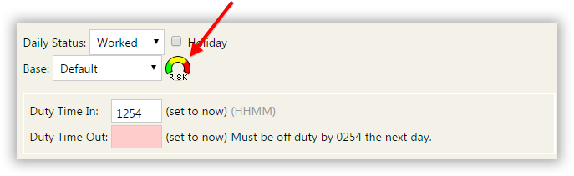

Figure 1

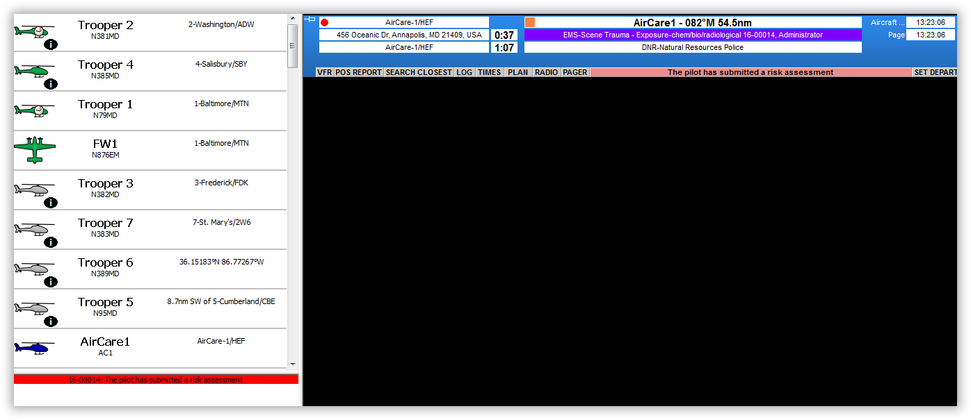
Figure 2
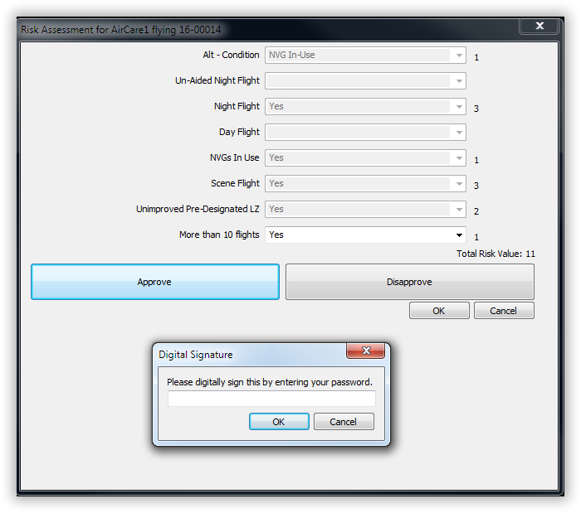

Figure 3

